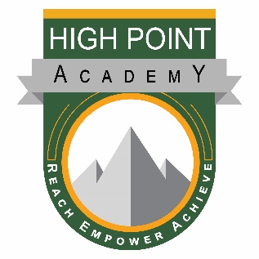

High Point Academy’s mission is to provide a strong foundation of academic excellence in partnership with family and community in which each individual is challenged to achieve his/her highest potential academically, socially, and personally.

Governing Board Meeting Agenda for:
October 23rd, 2019
5:00 PM – 7:00 PM

Board Attendance:
Other Attendance:

- Call to order – Christi Julian (5:00)

- Approve Agenda – Christi Julian

- Approve Board meeting minutes:
a. September 25, 2019
b. October 19, 2019

- Community Voices – (5:05)

- Reports: (5:10)
  - Executive Director-Keri Melmed

- Finances: (5:30)
  - September 2019 Financials-Carol Meininger
  - Audit resolution – Carol Meininger

- Discussion (5:45)
  - Committee Updates:
Finance Committee
School Accountability Committee
Safety Committee
b. Bonus Incentive
c. Connect for Success update
d. Student Achievement Data/STAR BOY – Q1

- Executive Items
a. Follow up on Preschool Funding Investigation

- Executive Session

- Approval items:
a. Audit Resolution

- Adjourn Meeting – Christi Julian (7:00)

