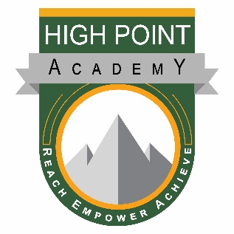

High Point Academy’s mission is to provide a strong foundation of academic excellence in partnership with family and community in which each individual is challenged to achieve his/her highest potential academically, socially, and personally.

Governing Board Retreat Agenda for:
July 20, 2019
10:00 AM – 12:00 PM

- Call to order – Christi Julian (10:00)

- Board Training – Jen Douglas (10:05)
- Legal Responsibilities
- Board Roles & Responsibilities
- Building a Strategic Board and Onboarding

- Adjourn Meeting – Christi Julian (12:00)

